**LEX CALCULATOR**

**Program:**

%{

int op = 0, i;

float a, b;

%}

dig [0-9]+|([0-9]*)[.]([0-9]+)

add "+"

sub "-"

mul "*"

div "/"

pow "^"

ln \n

%%

{dig} {digi();}

{add} {op=1;}

{sub} {op=2;}

{mul} {op=3;}

{div} {op=4;}

{pow} {op=5;}

{ln} {printf("\n The Answer: %f\n\n", a);}

%%

int digi()

{

if (op == 0)

a = atof(yytext);

else

{

b = atof(yytext);

switch (op)

{

case 1: a = a + b; break;

case 2: a = a - b; break;

case 3: a = a * b; break;

case 4: a = a / b; break;

case 5: for (i = a; b > 1; b--)

a = a * i;

break;

}

op = 0;

}

return 0;

}

int main(int argv, char *argc[])

{

yylex();

return 0;

}

int yywrap()

{

return 1;

}

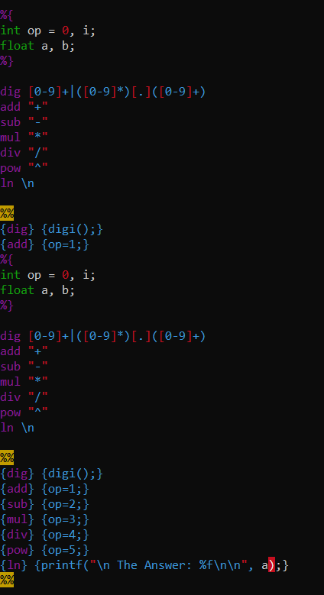

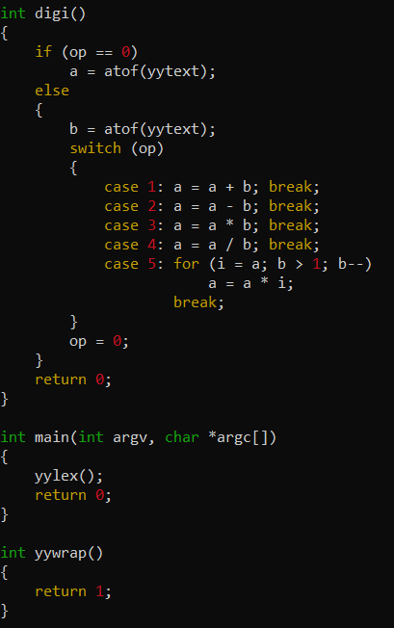

**Output:**

